**CSE 3241 Project Checkpoint 03 – SQL and More SQL**

Names: Lance Chen; Han Han, Yuliang Fu, Tongshuai Zhang Date: 10/25/2018

**Part One:** Submit a current version of your ER Diagram and Relational Model as 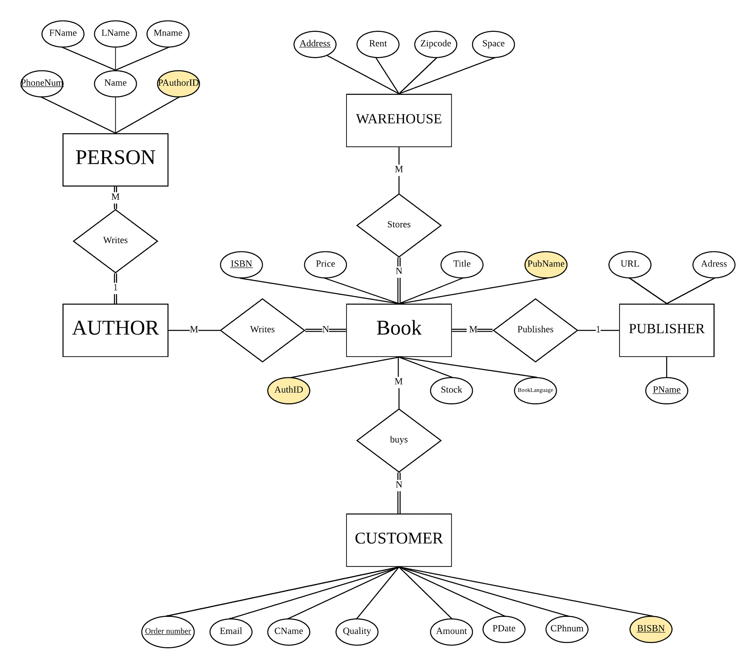

* **AUTHOR**: AuthorID
* **PERSON:** Fname, Lname, Mname, PhoneNum, **PAuthorID**
* **WAREHOUSE:** Address, Rent, ZipCode, Space
* **BOOK**: ISBN, Price, Title, Condition, Stock,BookLanguage, **PubName, AuthID**
* **PUBLISHER**: PName, URL, Address
* **CUSTOMER:** OrderNum,CName,CPhNum,Quantity,Amount, PDate,Email, **BISBN**
* **BOOK_WrittenBy_AUTHOR: BKISBN, AuID**
* **CUSTOMER_BUYS_BOOK: BookISBN, CusOrderNum**
* **WAREHOUSE_STORES_BOOK: BoISBN ,Wadresss**